Core Collection – Class Roster

- Responsibilities and Requirements
- Validation Tool
- Uploading Class Roster Data
- Promoting Class Roster Data
- Validating Class Roster Data
- Verifying Class Roster Reports
- Preparing/Finalizing Class Roster Data

TSDS Class Roster Core Collection

Class Roster – Submission Purpose, Responsibilities & Requirements

The Class Roster collection is used to report data about course offerings, teacher demographics, teacher class assignments, student demographics, and student class enrollments.

The data is used to create a student assessment data portal accessible by school districts, teachers, parents, students, and public institutions of higher education.

TSDS Class Roster collection allows TEA to provide the assessment vendor Winter class roster information in advance of STAAR and EOC assessments occurring in May. This provides the assessment vendor the information required to link a student’s assessment results to the teacher who provided the associated instruction.

This allows TEA to provide assessment results through the assessment portal at the individual classroom level, and it provides data for the Teacher Incentive Allotment calculation.

2023-2024 Class Roster Submission Timeline

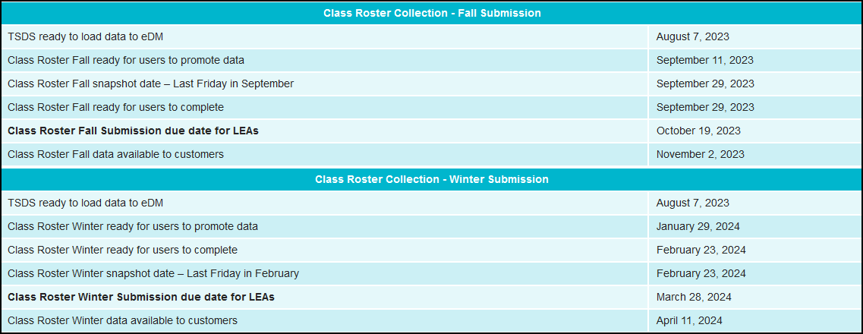

Class Roster Winter Submission

Only LEA-employed, contracted staff, or teachers employed at the in-district charter campus by an organization that has been granted a campus charter under TEC, Chapter 12, Subchapter C and is eligible for benefits under TEC, §11.174 and 11.147(b) serving an LEA as of the last Friday in February who have a ROLE-ID 087 (Teacher) or ROLE-ID 047 (Long-term Substitute Teacher) should be reported.

For the Class Roster Winter Submission, report TeacherSectionAssociationExtension for all teachers of courses offered in grades EE-12 as of the last Friday in February.
Each SectionExtension complex type should have at least one corresponding TeacherSectionAssociationExtension Complex Type for the teacher and a corresponding studentSectionAssociation Complex Type for each student assigned to that course.
A SectionExtension reported with a NON-CAMPUS-BASED-INSTRUCTION-CODE indicating that it is not taught by a school district/charter employee or contracted teacher or is taught at a facility other than where the student is enrolled, may be reported without a corresponding TeacherSectionAssociationExtension Complex Type.

Teacher Incentive Allotment Designation Information-CRW

TX-TeacherIncentiveAllotmentDesignation is collected in the Class Roster Winter Submission only.

It must be reported for each teacher (ROLE-ID 087) reported with a TEACHER-INCENTIVE-ALLOTMENT-DESIGNATION-CODE (E1722) in the current school year.
The TX-TeacherIncentiveAllotmentDesignation Complex Type indicates the designation held by a teacher or that a teacher has been submitted by an LEA for new or change of designation. If the teacher does not hold a designation and has not been submitted by their LEA for a new or change of designation, the complex type will not be reported.
TEACHER-INCENTIVE-ALLOTMENT-DESIGNATION-CODE (E1722) indicates a teacher (ROLE-ID 087) is an Active National Board Certified Teacher, holds a current designation (Recognized, Exemplary, or Master) and/or has been submitted by an LEA for a new or change of designation in the Teacher Incentive Allotment.
This data is reported based on code table DC165. More than one TEACHER-INCENTIVE-ALLOTMENT-DESIGNATION-CODE may be reported for each teacher. The TEACHER-INCENTIVE-ALLOTMENT-DESIGNATION-CODE data element is an “unbounded” data element within the TX-TeacherIncentiveAllotmentDesignation sub-complex type. Therefore, the TEACHER-INCENTIVE-ALLOTMENT-DESIGNATION-CODE data element can be repeated within the TX-TeacherIncentiveAllotmentDesignations sub-complex.
Report designated teachers in an atypical teaching position using the TeacherSchoolAssociation.
- Only report TeacherSchoolAssociation for TIA designated or National Board-Certified teachers without a TeacherSectionAssociation.
CREDITABLE-YEAR-OF-SERVICE-INDICATOR-CODE indicates a teacher (ROLE-ID 087) who currently qualifies for the TIA allotment or has been submitted by the LEA for a new or change of designation and has been employed by the LEA and compensated or will be compensated by the LEA for a creditable year of service. (§153.1021)
Creditable year of service for the teacher incentive allotment purposes is defined as 90 days at 100% of the day (equivalent to four and one-half months or a full semester) or 180 days required at 50-99% of the day. (§153.1021)

CREDITABLE-YEAR-OF-SERVICE-INDICATOR-CODE is only reported for teachers designated or pending designation for the Teacher Incentive Allotment.

Staff
Identification, demographic and class assignment.

Class Roster Winter Submission: The TeacherSchoolAssociation complex type must be reported for each teacher (ROLE-ID 087) reported with a TEACHER-INCENTIVE-ALLOTMENT-DESIGNATION-CODE (E1722) on the StaffExtension complex type if the teacher is not reported with a TeacherSectionAssociationExtension complex type.

Two data elements in the StaffExtension complex type:

- CREDITABLE-YEAR-OF-SERVICE-INDICATOR-CODE (E1721)
- TEACHER-INCENTIVE-ALLOTMENT-DESIGNATION-CODE(E1722)

Teacher Incentive Allotment Designation Code
- TEACHER-INCENTIVE-ALLOTMENT-DESIGNATION-CODE (DC165)

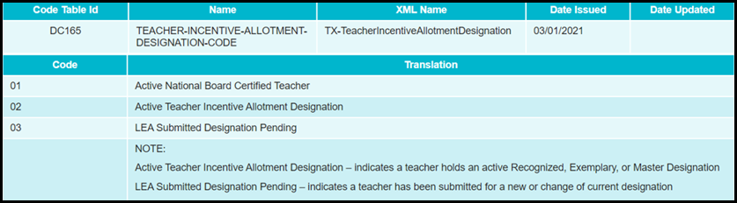

Student
Identification, demographic and class enrollment. The Class Roster Collection uses StudentSchoolAssociationExtension data in order to capture the ENTRY-GRADE-LEVEL-TYPE for each student.

TSDS Interchanges for Class Roster

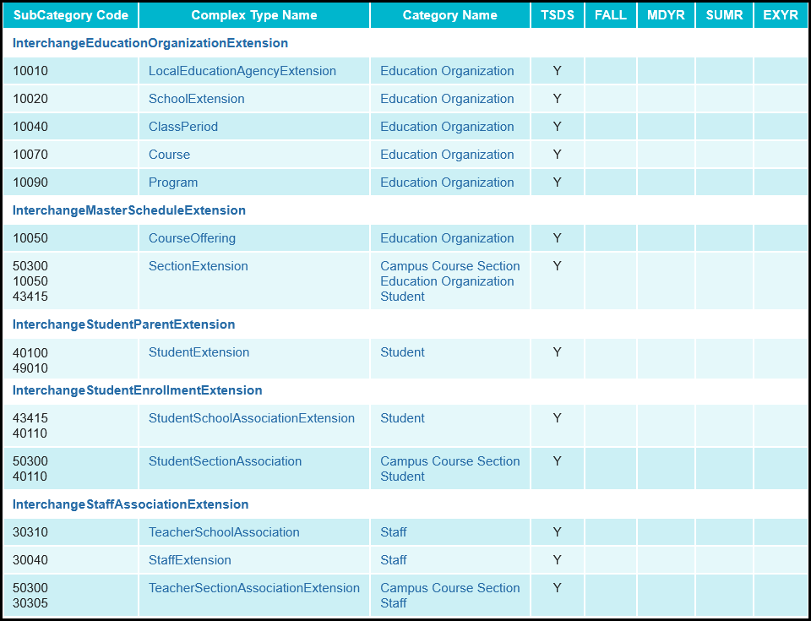

Class Roster Submission Requirements

For the Class Roster Collection, information from the Teacher Section Association Extension Complex Type is used to capture classroom assignments for certain classroom staff (Role IDs 087 and 047 only). This information is also used to link back to the Section Extension Complex Type in order to identify the classroom information associated with a teacher’s respective class assignments.

LEAs are required to report all teachers (Teachers of Record, Assistant Teachers, Support Teachers) that provide instructional services for a particular class. For example, if a teacher rotates through each of the third-grade classes providing a reading service to the students, then that teacher would have a “class role” (CLASSROOM-POSITION) of “Support Teacher” and would need to be assigned to and reported with each class that he/she provides the instructional reading service.

If more than one “Teacher of Record” is assigned to a class during the duration of the class, then all “Teachers of Record” must be reported on the TeacherSectionAssociationExtension Complex Type.

For each Teacher Section Association Extension complex type, there must be a matching Section Extension complex type with a matching CAMPUS-ID, CLASS-ID-NUMBER, and COURSE-SEQUENCE-CODE.
LEA-employed or contracted teaching staff (ROLE-IDs 087 Teacher 047 Long-term Substitute Teacher) should be reported for the Class Roster Winter Submission.
- For the Class Roster Winter Submission, report TeacherSectionAssociationExtension for all teachers of courses offered in grades EE-12 as of the last Friday in February.
For the ECDS and Class Roster Collections, LEAs must report the TeacherSectionAssociationExtension complex type. Each of these collections are reported as of different dates.
Local-credit courses such as the 8XXXXXXX series courses are not reported through the Classroom Link data reporting. Additionally, the Service IDs that begin with SS, SE, SR, and SA are excluded because these series of Service IDs are not valid for student records.

For teachers that are assigned to teach in a district operated DAEP program, the campus that the teacher is associated with reports the TeacherSectionAssociationExtension Complex Type reflecting the classes the teacher is teaching to DAEP students. If a student is placed in, or expelled to, a DAEP setting, the Teacher(s) of Record for the student will change due to the student being assigned to a new set of courses (Course Section) at the DAEP that are taught by teachers assigned to the DAEP program.

For teaching staff that are assigned to an in-district DAEP program (not a DAEP campus), the TeacherSectionAssociationExtension complex type should identify the teachers serving as either a “Teacher of Record”, “Assistant Teacher”, or “Support Teacher”.

If the teaching staff in charge of the DAEP classrooms are merely serving as a facilitator for the home campus Teacher(s) of Record of the students that are assigned to the DAEP, then the DAEP facilitators should not be reported with a TeacherSectionAssociationExtension complex type. In this scenario, the home campus Teacher(s) of Record will be reported with a TeacherSectionAssociationExtension complex type for the students assigned to the DAEP program. This will likely mean that the students assigned to a DAEP program in this situation will remain assigned to their course sections at the campus where they are still enrolled. Determining the “Teacher of Record” for students assigned to a DAEP program is based on the definition of “Teacher of Record”.

For home bound teachers serving home bound students on a short-term basis (less than a full grading period/semester), the home bound students served should remain assigned to the course section (teacher of record) they were assigned prior to moving into the home bound setting. For home bound teachers serving home bound students on a long-term basis (full grading periods/semesters/school year), the LEA should determine the “Teacher of Record” based on the definition of “Teacher of Record”.
For the Class Roster collection, each SectionExtension complex type should have at least one corresponding TeacherSectionAssociationExtension Complex Type for the teacher and a corresponding StudentSectionAssociation Complex Type for each student assigned to that course.

For students that are placed in or are expelled to a DAEP program, or expelled to a JJAEP, the campus that enrolls the student during these disciplinary removals is responsible for creating the SectionExtension Complex Type(s) that reflect the new course sections to which the student has been assigned while attending a DAEP or a JJAEP.
For each Section Extension Complex Type, there must be a matching Student Section Association Complex Type where CAMPUS-ID, CLASS-ID-NUMBER, and COURSE-SEQUENCE-CODE is the same. This rule ensures that each course section offered at a campus has at least one student assigned to that course section.

TSDS – Access and User Roles

The TSDS PEIMS application is only available to authorized ESC, district, and campus staff. A TEAL login is required as well as access to the Texas Student Data System Portal. Different roles can be assigned to the user based on the access required. There are seven different roles in the PEIMS application, each with a different level of access.

- ODS Data Loader (ESC/LEA) – This role allows the user to upload PEIMS and TSDS Interchanges to TSDS portal.
- Core LEA Data Promoter – This role allows the user to promote data, validate (prepare) data, schedule and view data reports.
- Core LEA Data Completer – This role allows the user to promote loaded data, validate (prepare) data, complete (finalize) data and view reports at the district level.
- Core LEA Data Approver (LEA Superintendent) – This role allows the Superintendent to request an extension for the submission. The Superintendent does not approve this submission.
- Core Lea Data Viewer – This role allows the user to only view the reports.
- Core ESC Data Viewer - This role allows the user at the ESC to view and monitor the submission.

Download the Validation Tool

TEA provides a Validation Tool to validate the format and naming conventions for the PEIMS interchanges. The Validation Tool is located in TEAL>Texas Student Data System Portal>Utilities for downloading. This must be done to update to the most recent Validation Tool version.

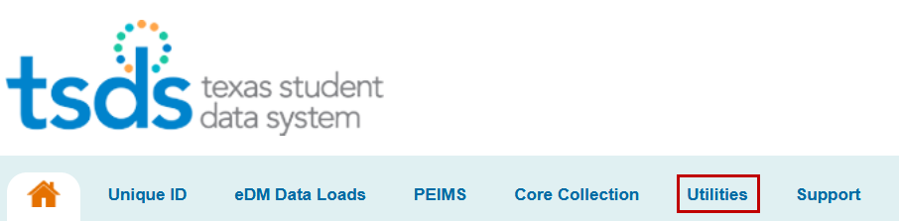
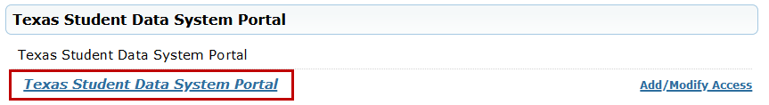

Follow the screenshots below.

Download and Install the Validation Tool on your Desktop.

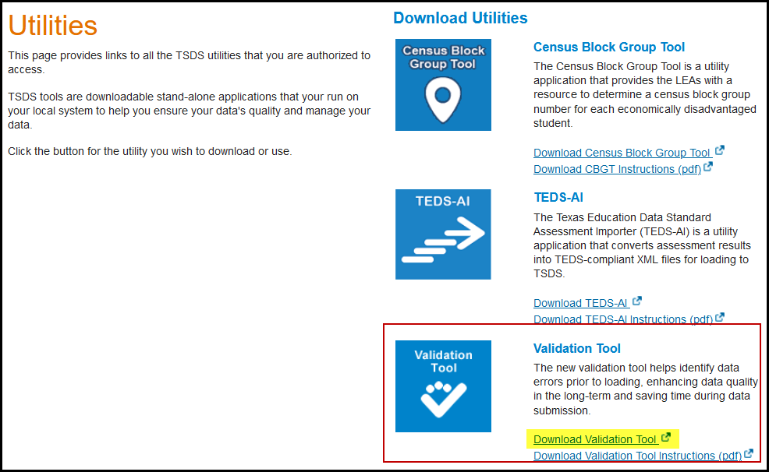

Click on Download Validation Tool
- Save the executable file
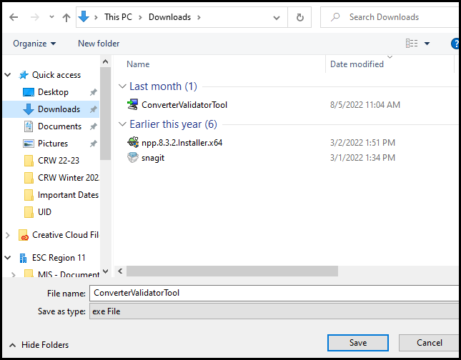

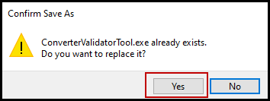

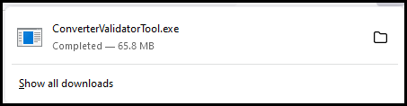

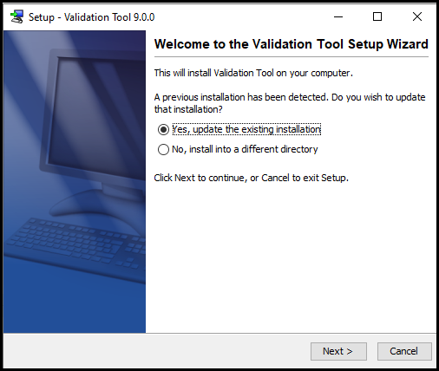

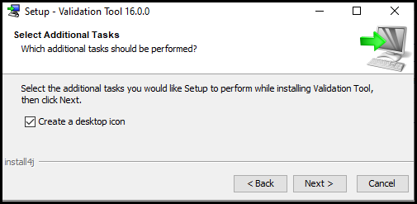

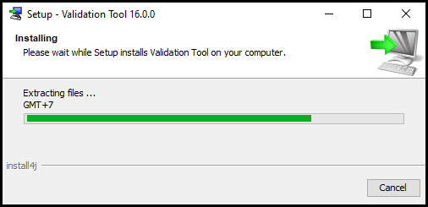

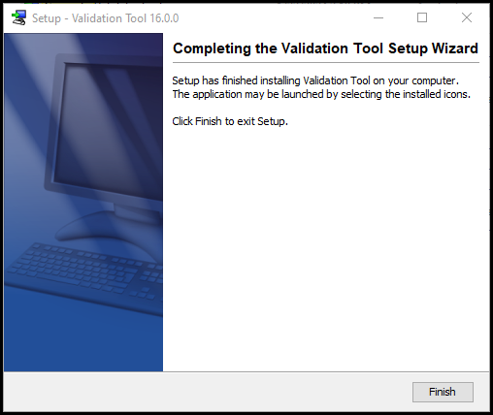

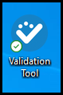
Icon on Desktop:

Validation Tool: Help and Information
Help – Directs you to the TSDS Conversion and Validation Tool User Guide
About – View the version number

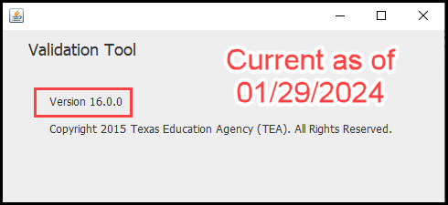

Validating PEIMS & TSDS Interchanges

Once the Validation Tool has been downloaded and installed click on the validation tool icon to open the tool.
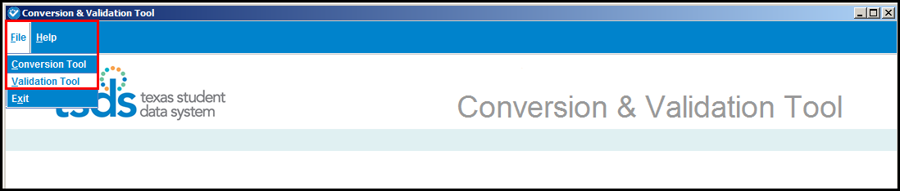
- Select File > Validation Tool. The Validation Tool opens in a separate window.

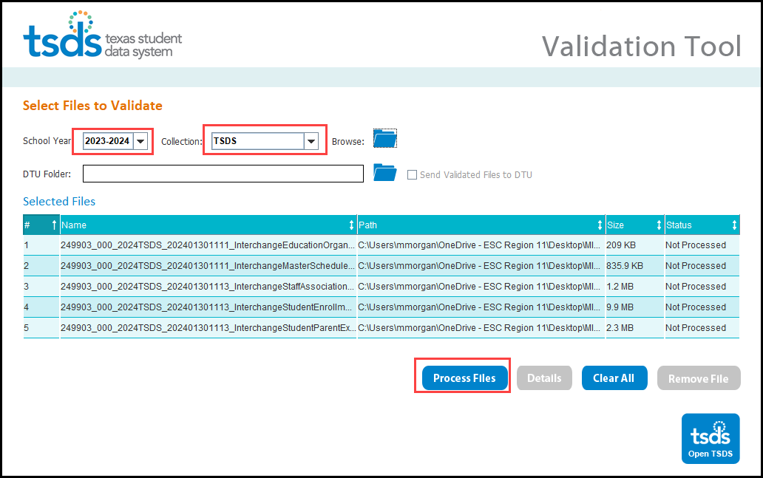

- Select the School Year 2023-2024.
- Select the TSDS Collection.
- Click the folder icon to browse for and select the Class Roster files (files must be unzipped).
- Click Process Files. The results of the validation are reported in the status field.
- If you have files that Fail, you can click on the file name and click the Details button.

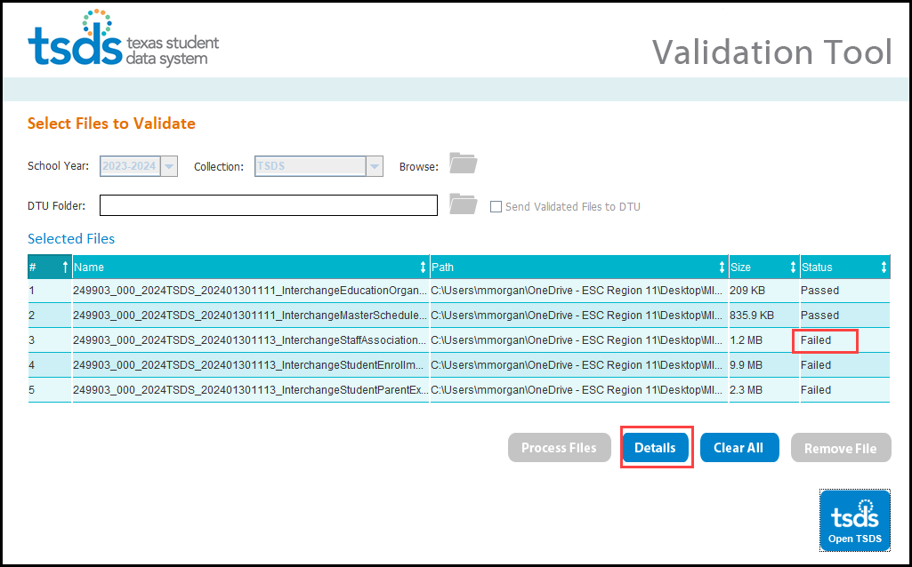

- The Detail Errors page appears, errors can be viewed on screen by selecting Error Type (All, Fatal, Warning, or Special Warning).
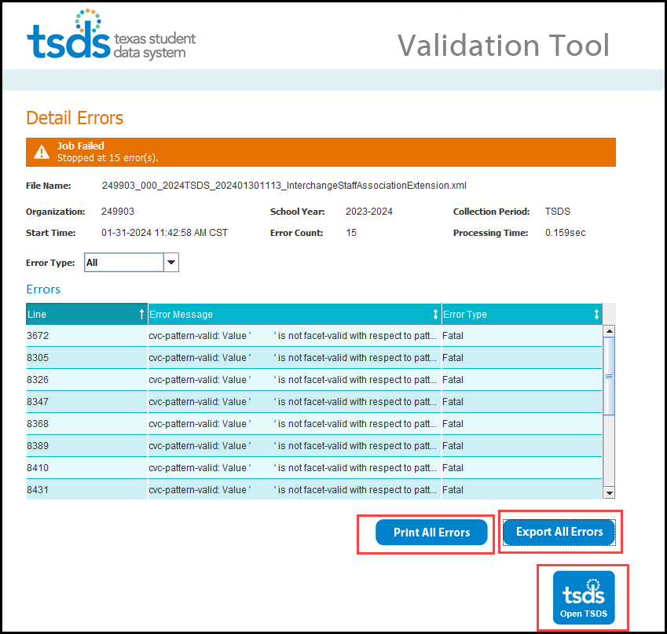

- Errors may also be printed by selecting Print All Errors or saved in Excel format by selecting Export All Errors.

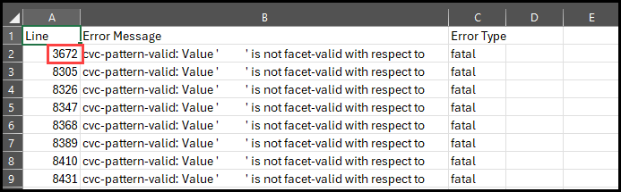

- Files can be manually loaded in TSDS by clicking on the Open TSDS button. This will take you to the TEAL login screen.

Note: Failed files will not load in TSDS. Files with errors will load, but errors will need to be corrected prior to finalizing the Class Roster Submission.
Uploading TSDS files – TSDS Data Upload

The TSDS portal is the way to access any of the TSDS applications or utilities to which users have rights. The tabs that appear on the portal depend upon the access that has been granted in TEAL.

The eDM Data Loads tool allows users to load data from their local systems to TSDS.

- Once logged into TEAL and select Texas Student Data System Portal.
- On the Home screen select Manage Data Loads.
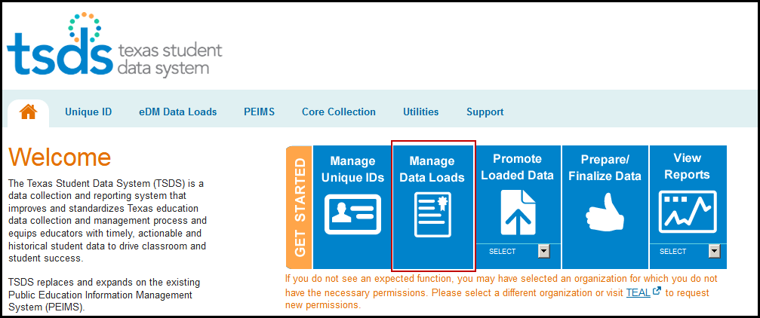
- ––Under Interchange Menu, select Interchange Upload.

- Select the 2024 TSDS from the drop-down menu.
- Click the Browse button for File 1 and select the file from your computer.
- Click the Browse button for File 2 and select the next file from your computer.
- Continue until all required files have been selected.
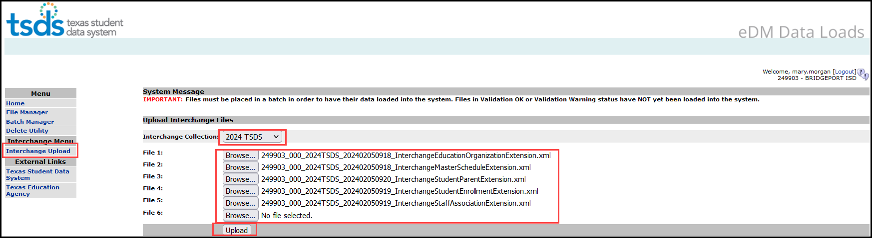

Note: The files must be loaded in the following order:

- InterchangeEducationOrganizationExtension
- InterchangeMasterScheduleExtension
- InterchangeStudenParentExtension
- InterchangeStudentEnrollmentExtension
- InterchangeStaffAssociationExtension

- Click Upload. The files are validated and uploaded to the File Manager.

Note: Files can be zipped for easier upload. Select all files, right click, Send to>Compressed (zipped) folder. Upload the one file.
Do not close this screen while files are uploading. You may exit once the File Manager screen appears.

- Once the files have been completely uploaded, the File Manager screen appears.
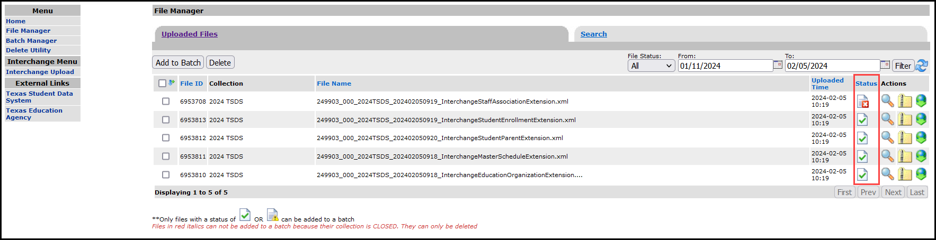
- Verify you have green checkboxes in the Status column.

- The files will be processed for errors.

- Any failed files will not batch.
- Any files with errors will have a in the status column. To view errors, click the spyglass and scroll to the bottom of the screen. Click the spyglass by the .TAB file. Or error.zip file.
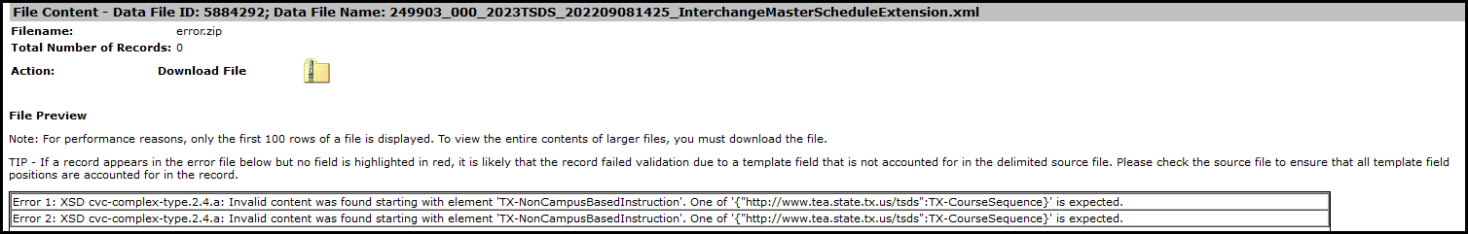

- Make all corrections necessary in the software, run the Validation Tool again, and re-upload the files.

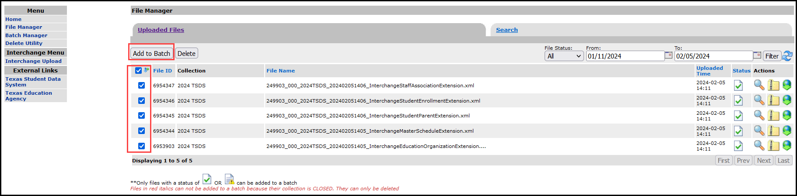
- Once all the files have a green checkmark in the status column, select all of the files and click Add to Batch.

- The View Batch button appears.
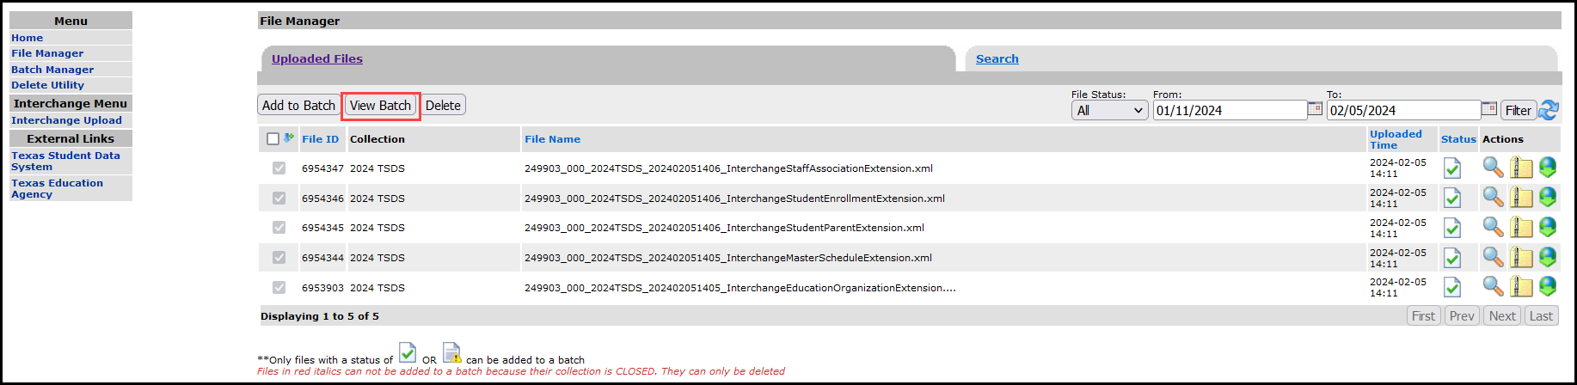
- Select the View Batch button.

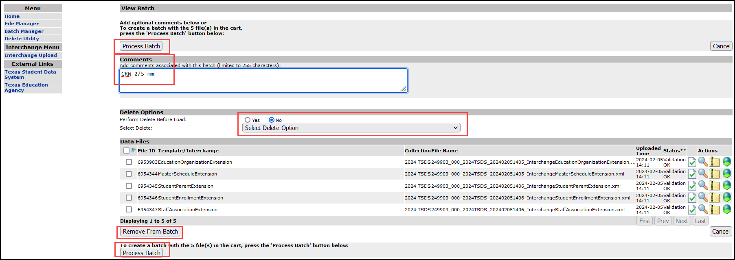
- From the next screen the user may add comments regarding the batch, remove files from the batch, delete files, or process the batch. It is suggested that comments be added naming the
file if the files are being uploaded manually.

- To remove files from the batch, select the appropriate files and click Remove from Batch.
- The selected file is removed from the View Batch screen but remains in the File Manager.

- Districts can delete data prior to processing the new batch. The Delete Utility has been integrated into the Batch Manager process.
- To delete data, select Yes by Perform Delete Before Load.
- From the Select Delete Option pulldown, select the data to be deleted.

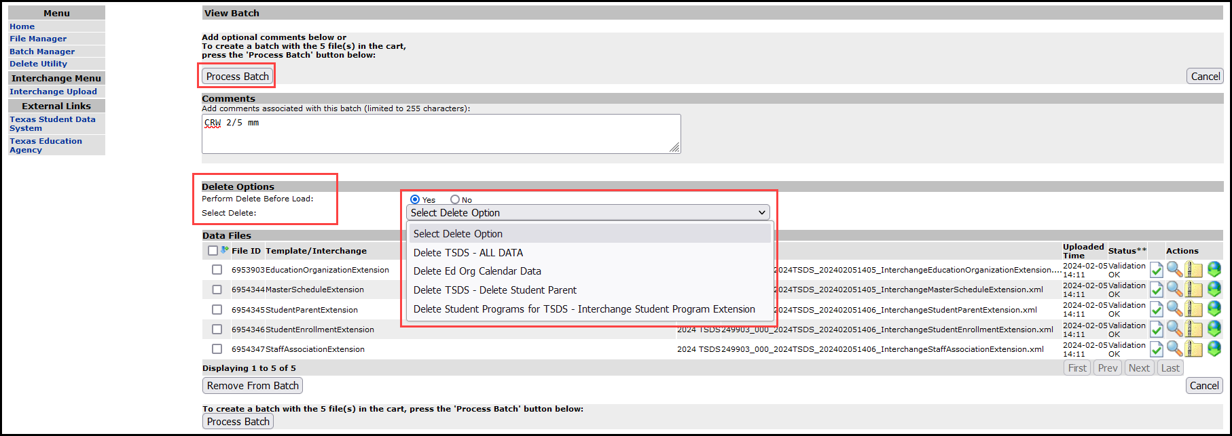
- To process the batch, select the appropriate files and click Process Batch. The Batch Manager screen appears:

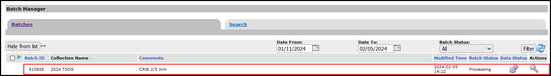

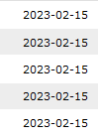
- The Batch Manager screen appears with a list and status of all batches that have been processed. Batches can have a completed status with errors (red X) or no errors (green checkmark).
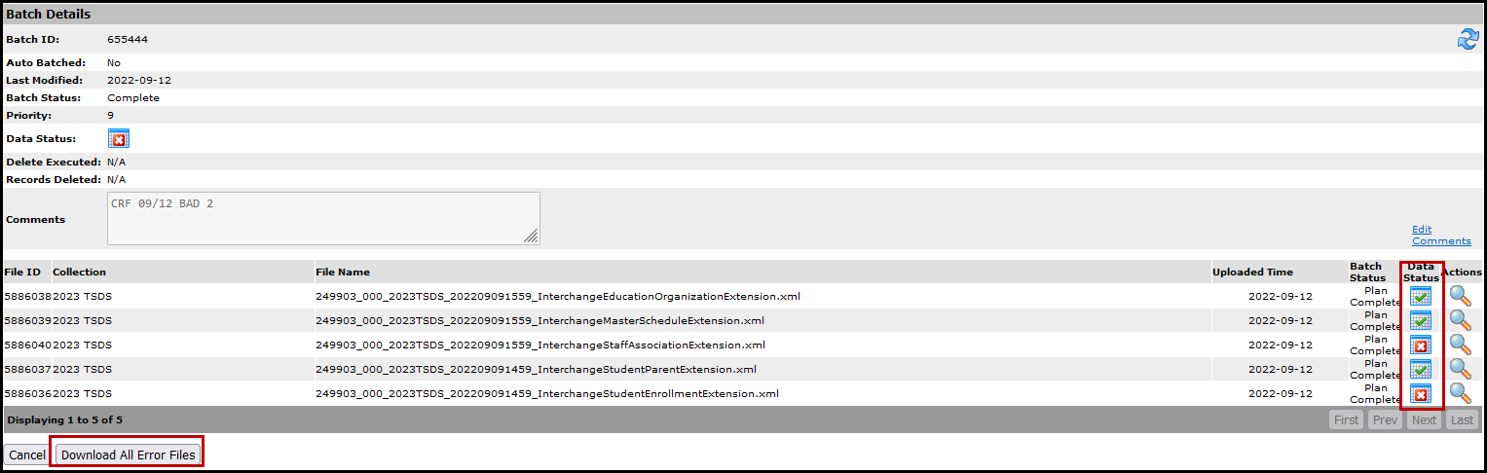
- To view the files with errors, click the spyglass to open the batch and then click on the spyglass next to the file with errors; or
- Click on Download All Error Files.
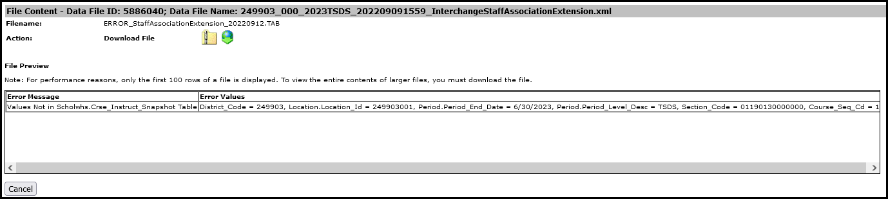
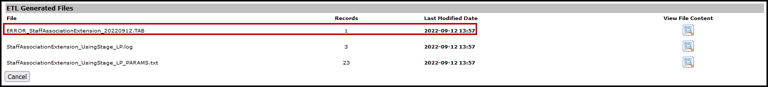
- To view the actual errors, click on the spyglass next to the .TAB file.

- Click Cancel to return to previous screens.
- Make corrections as needed in the software, create new interchanges, validate again, and resubmit the files.

Promoting Class Roster files – Core Collection Promote Loaded Data

The eDM Promote Loaded Data tool allows users to promote data that has been loaded and batched.

- Log in to TEAL and select Texas Student Data System Portal.
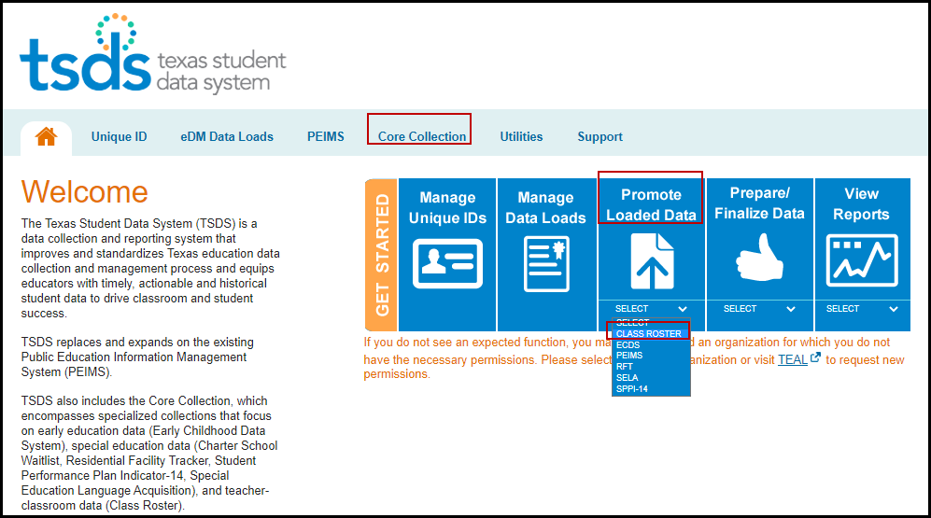
- On the Home screen select Core Collection>Promote Loaded Data.

- The Data Promotion screen appears:

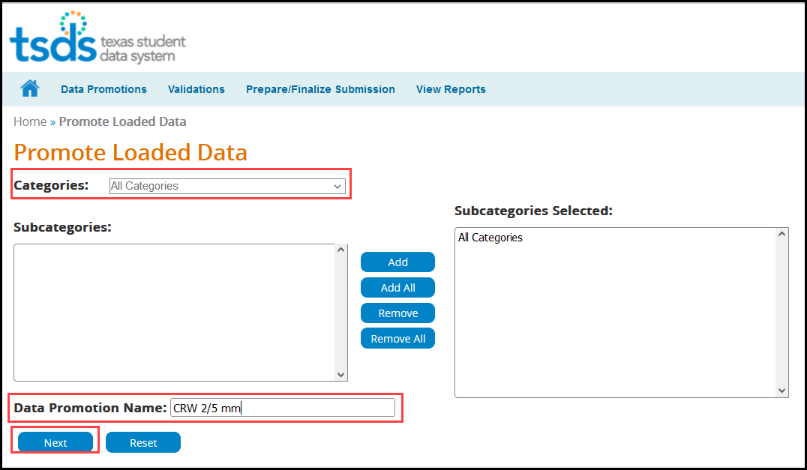

- Verify the correct submission is selected. If not, select it from the pull-down menu and click GO.
- From the Categories pull-down menu, select All Categories or the individual categories to be promoted. If individual categories are selected user may also select individual subcategories.
- Enter a Data Promotion Name.
- Click Next to continue or Reset to clear selections.
- The Confirm Data Promotion screen appears:
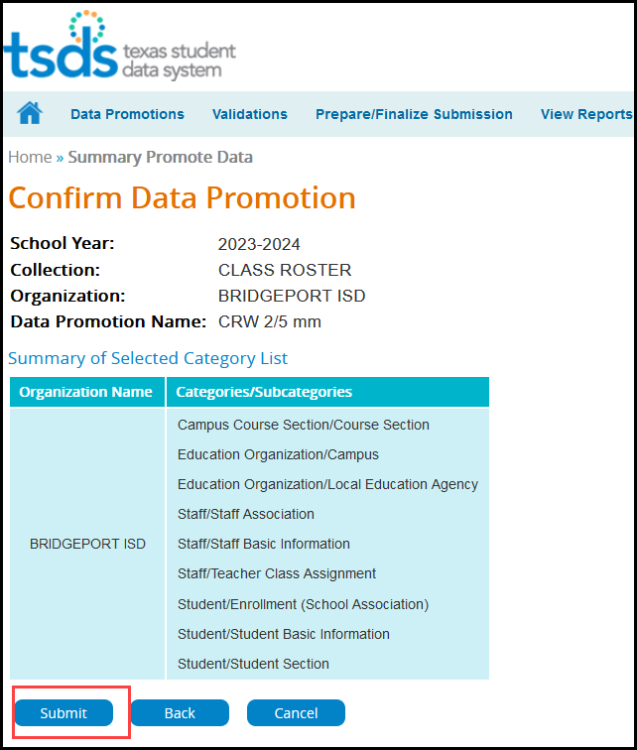

- Verify the Categories/Subcategories
- Click Submit, Cancel, or Back.
- The Monitor Data Promotions screen appears:

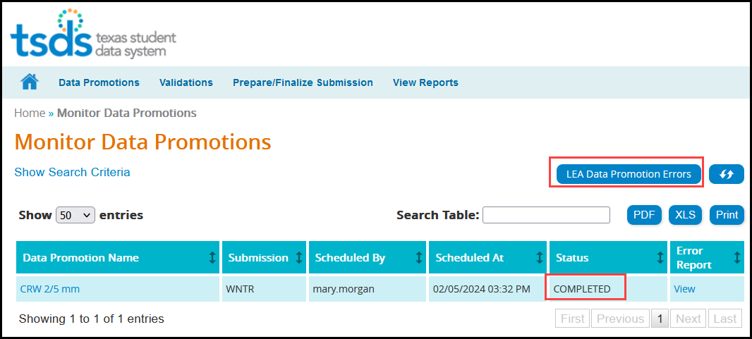

- This screen shows the status of the data promotion, promotion error reports, and a confirmation message that the data was promoted.
- To view any promotion errors, click the View link under Error Report or click the LEA Promotion Errors button.
- The Data Load Error Report by Job screen appears:

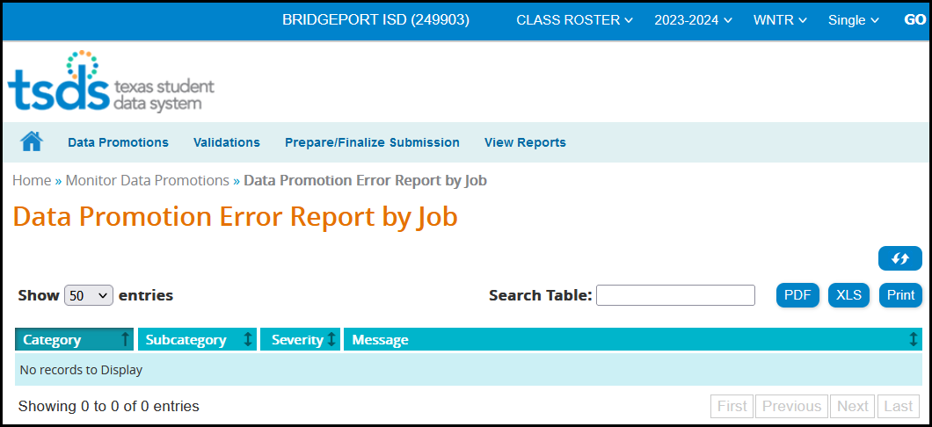

- This screen will list any errors by Category, Subcategory, Severity, along with the error message. Errors can be saved as a PDF or XLS file or can be printed by selecting the appropriate button.

Validating Class Roster files – TSDS Core Promote Loaded Data>Validations

The eDM Promote Loaded Data tool also allows users to validate data that has promoted in TSDS. This is where the district will be able to view the Fatals, Warnings, and Special Warnings for the submission.

- Log in to TEAL and select Texas Student Data System Portal.
- On the Home screen select Promote Loaded Data. Select the Validations tab>Validate Submission Data.

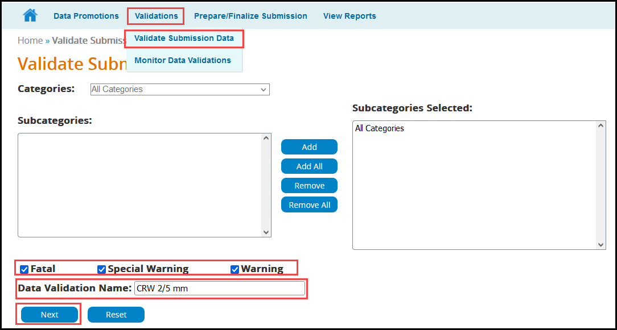

- From the Categories pull-down menu, select All Categories or the individual categories that are to be validated.
- Select the type of validation (Fatal, Warning, Special Warning).
- Enter a Validation Name.
- Click Next to continue the process or Reset to clear all options.

- The Confirm Data Validation screen appears:
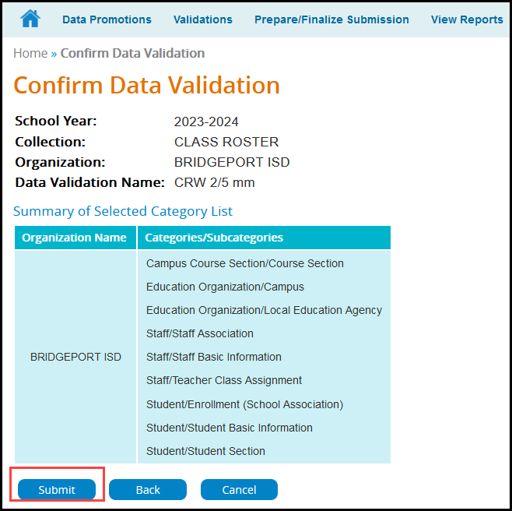

- Verify the Categories/Subcategories
- Click Submit, Cancel, or Back.
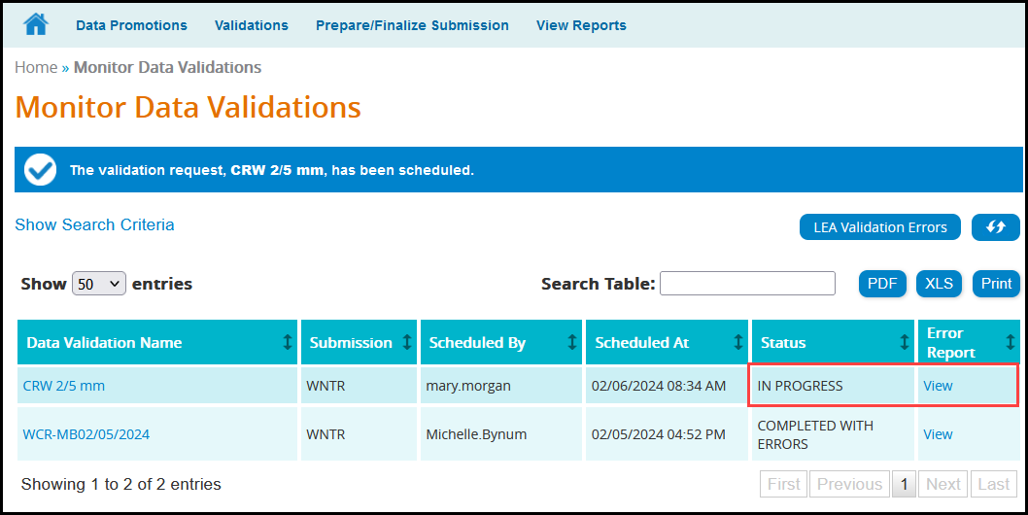
- The Monitor Data Validations screen appears:

- This screen shows the status of the data validations, validation error reports, and a confirmation message that the data has been submitted.

- To view validation errors by job, click the LEA Validation Errors button or View under Error Report.

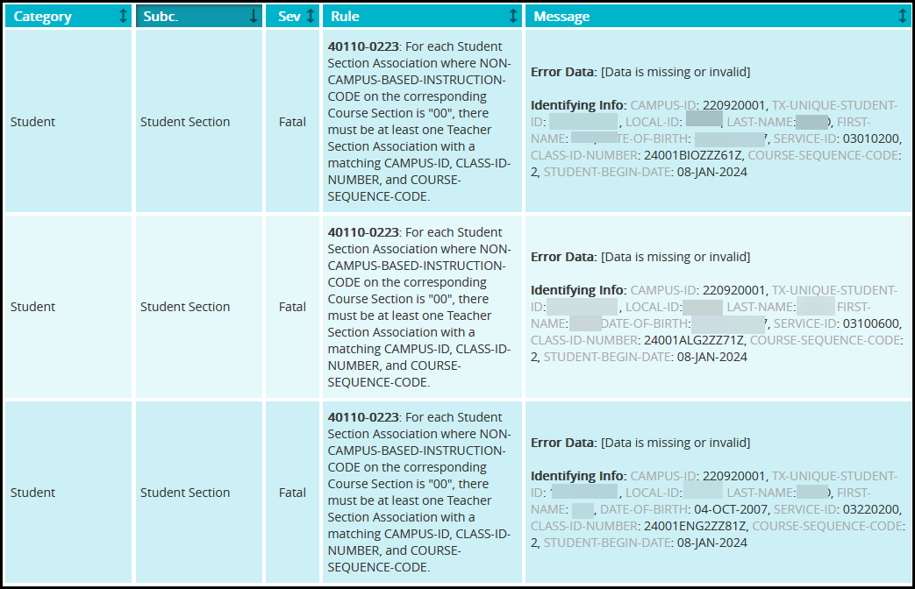
- This screen will list any errors by Category, Subcategory, Severity, along with the error message.
- Errors can be sorted by the individual columns. The errors can also be saved as a PDF or XLS file or can be printed by selecting the appropriate button.
- The Search Table option can be used to search the errors by any field such as Rule Number, Student UID, specific Category or Subcategory, etc.

Note: It is recommended that the district use the Delete Utility in TSDS>Manage Data Loads to clear the incorrect data from the ODS prior to uploading the new files.

View Reports – Class Roster Reports

Reports must be run and verified prior to and after completing the Class Roster data submission.

To access the reports:

- Log in to TEAL and select Texas Student Data System Portal.

- On the Home screen select CLASS ROSTER under View Reports. Click View Reports.
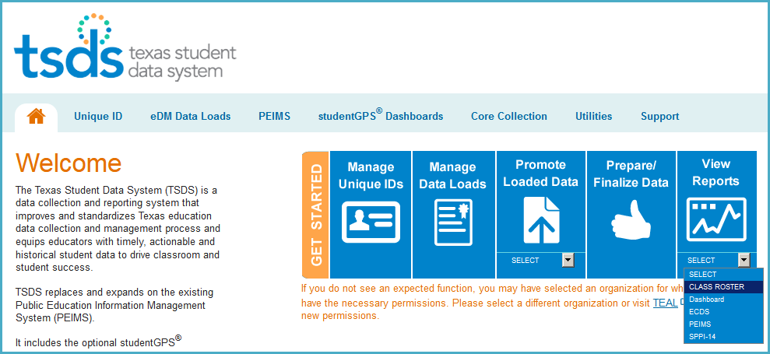

- Or, reports can be accessed in Core Collection>View Reports>CLASS ROSTER
Select CLASS ROSTER under View Reports. Click View Reports.
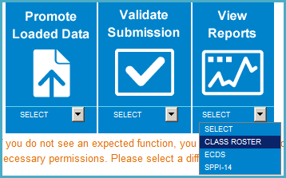

- Under View Reports, click the arrow in the Run column for the appropriate report.
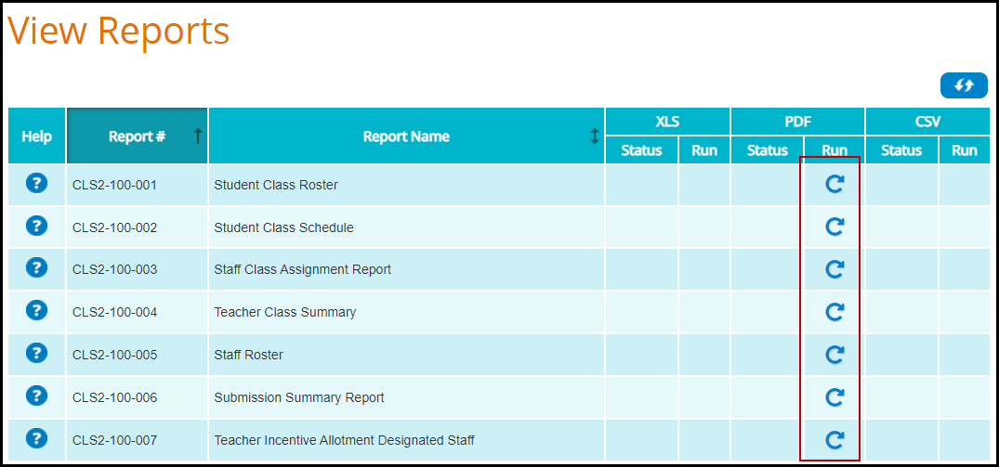

Class Roster Winter
- The Student Class Roster CLS2-100-001 report requires Parameters be selected. Select the appropriate parameters and click Run.
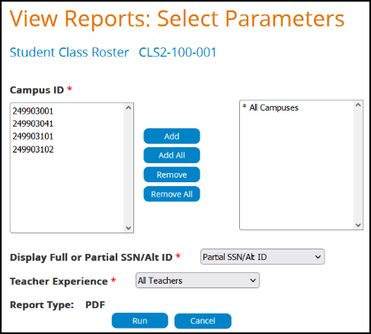

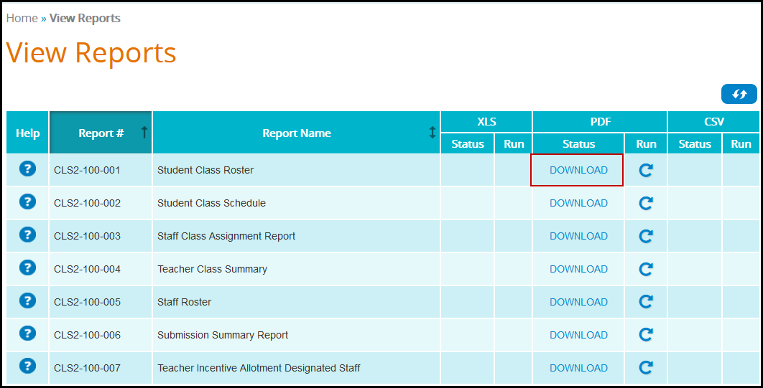
- Click Download to view the report.
CLS2-100-001 Student Class Roster
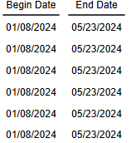
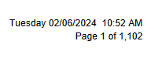
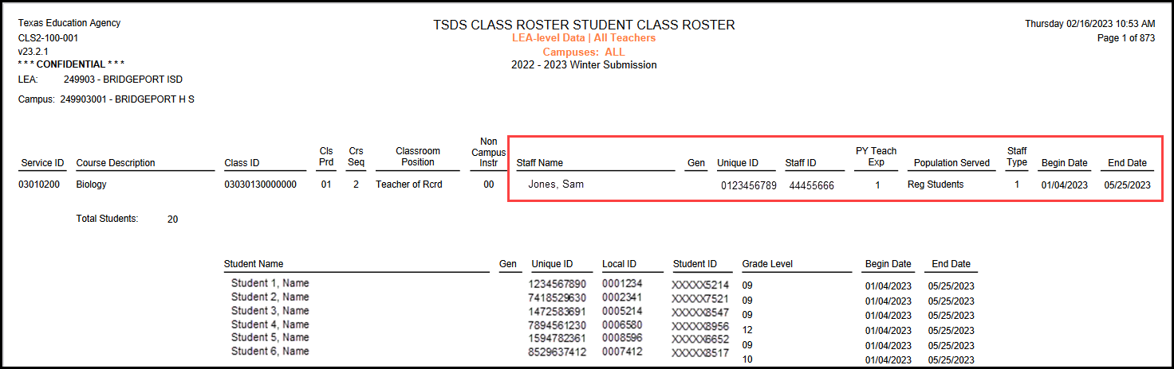
- This report lists class and teacher information, including a list of students attending each class.
- LEAs should verify the data they have submitted for each teacher’s Service IDs.

CLS2-100-002 Student Class Schedule Report

- The Student Class Schedule report requires Parameters be selected. Select the appropriate parameters and click Run.
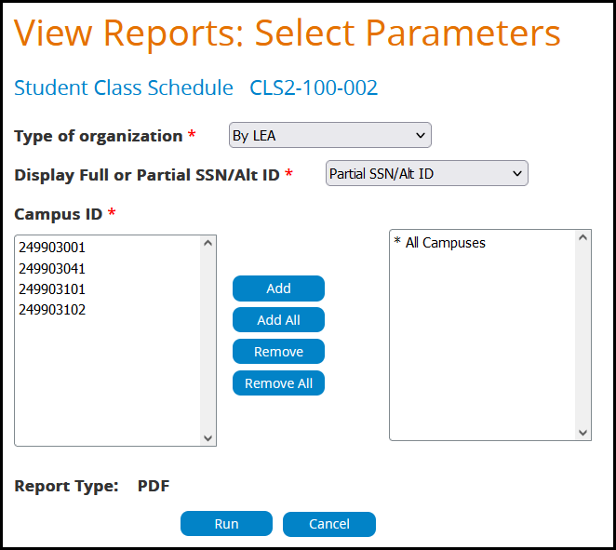

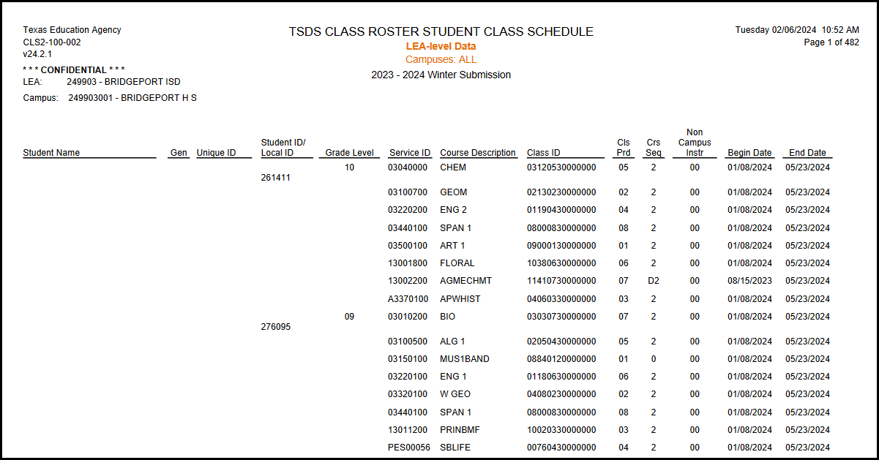

- This report will provide a listing of students with their class assignment schedules and class attributes.
- LEAs should verify the data they have submitted for each student’s class schedule.

CLS2-100-003 Staff Class Assignment Report

- The Staff Class Assignment report requires Parameters be selected. Select the appropriate parameters and click Run.
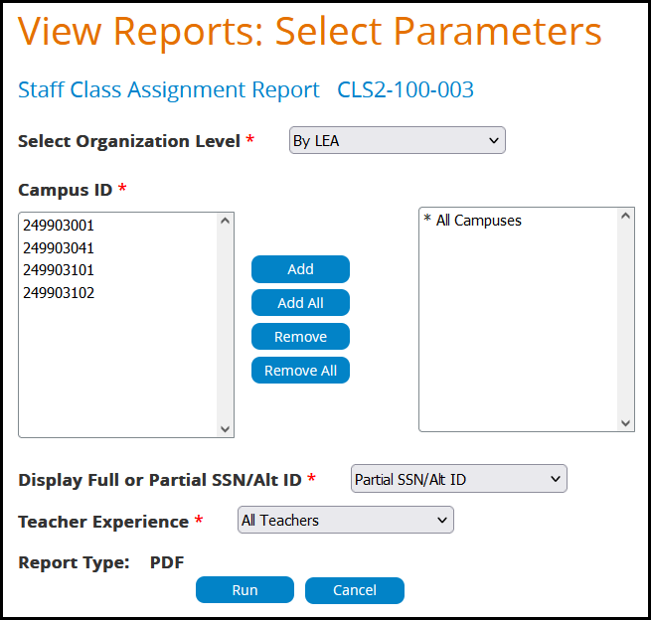

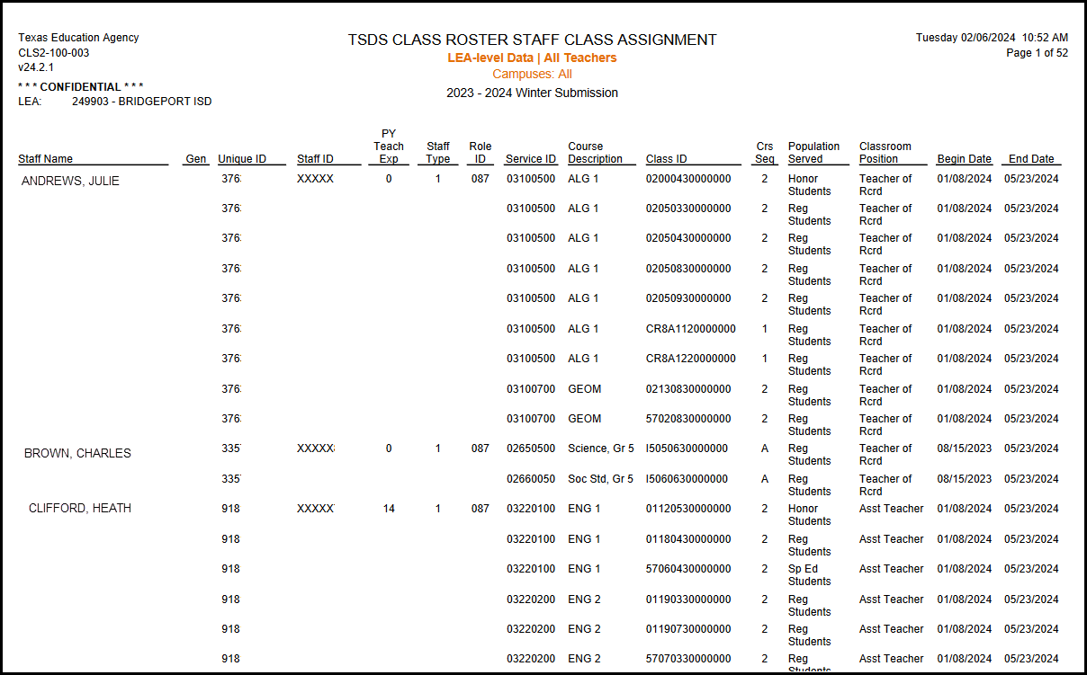

- This report lists the staff arranged alphabetically along with classroom attributes.
- The report can be generated on all teachers or only beginning teachers.

CLS2-100-004 Teacher Class Summary

- The Teacher Class Summary report requires Parameters be selected. Select the appropriate parameters and click Run.

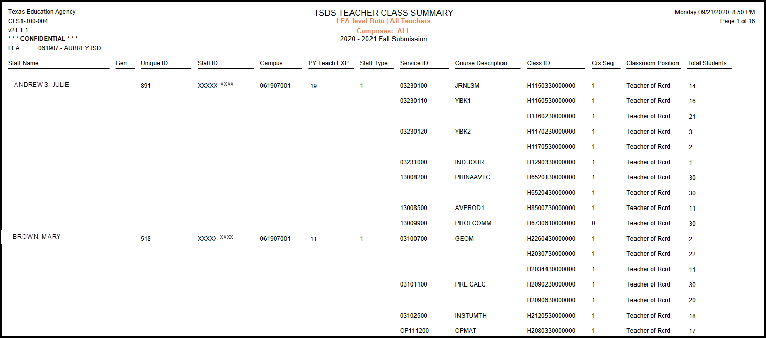
- This report summarizes teacher and class information for all grade levels for Winter submission, including student counts.

- The report can be generated on all teachers or only beginning teachers.

CLS2-001-005 Staff Roster

- The Staff Roster report requires Parameters be selected. Select the appropriate parameters
and click Run.

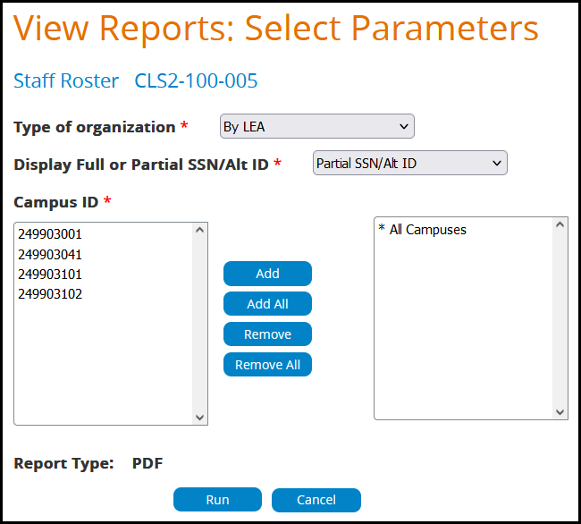

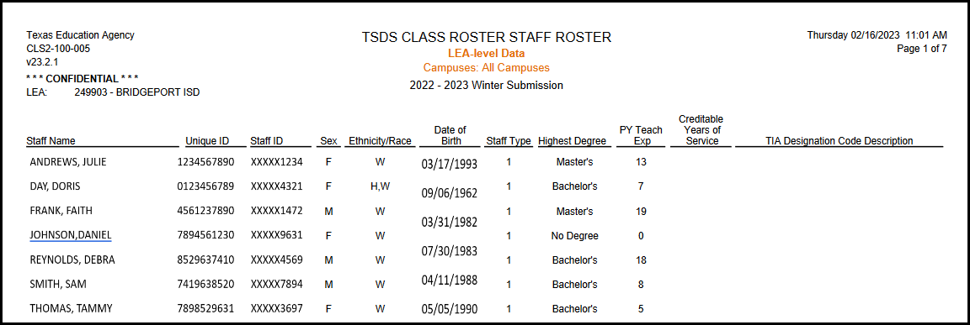
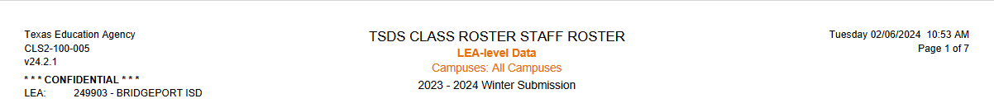
- This report provides a staff roster listing and summarizes individual staff profiles in alphabetical order by last name.
- LEAs should verfity the data they have submitted for each staff member.

CLS2-100-006 Submission Summary Report

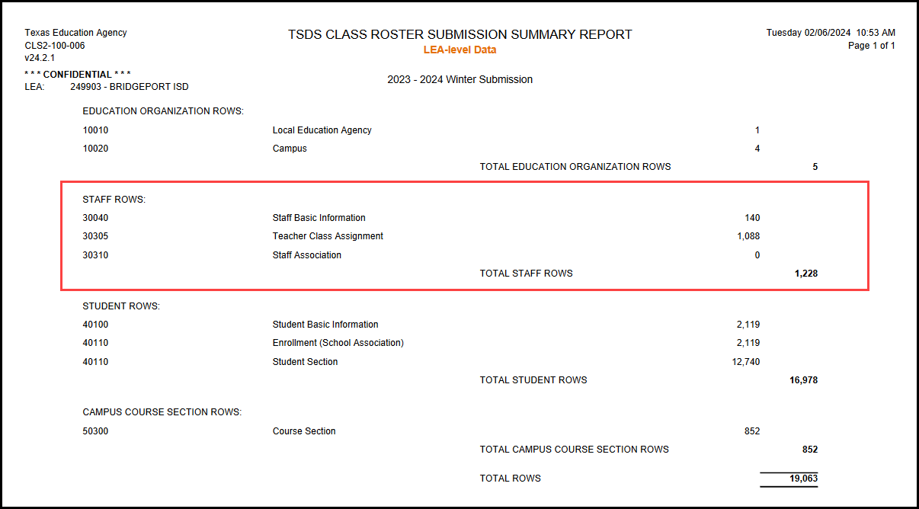
- The Submission Summary Report does not require Parameters to be selected. Click Run.

- This report displays row counts by category and subcategory.

CLS2-100-007 Teacher Incentive Allotment Designated Staff
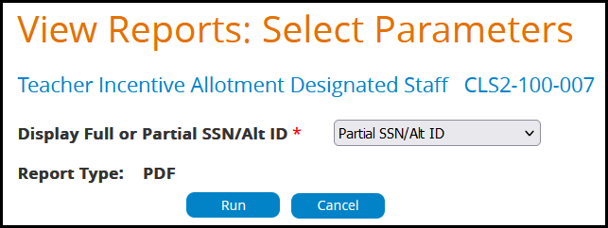

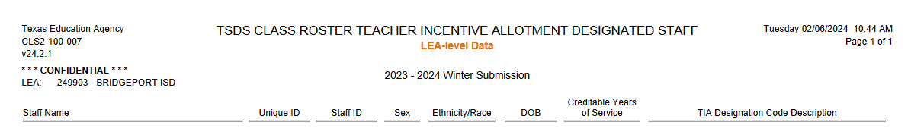
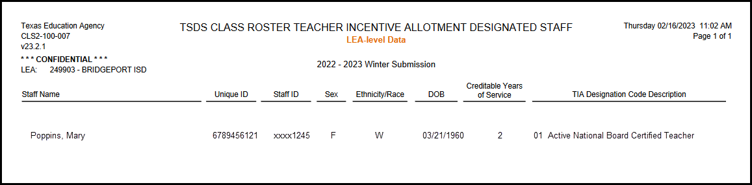
- Teacher data for all teachers with a TIA designation code(s)
- Campuses at which the teachers provide instruction, in order for LEAs to verify the designated campuses for funding.

Administration Tab
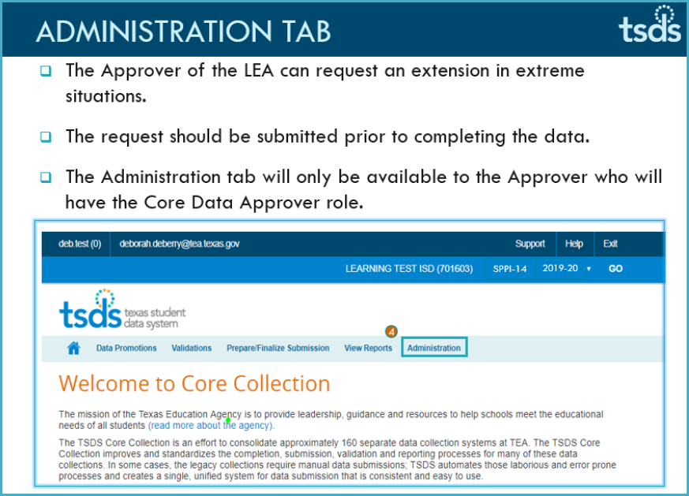

TSDS –Class Roster Prepare/Finalize Process

Finalize the Collection only when:
- The Collection is Fatal free
- All Special Warnings and Warnings have been verified, and
- All Reports have been reviewed for completeness and accuracy.

Select Prepare/Finalize Data Prepare/Finalize(Class Roster)

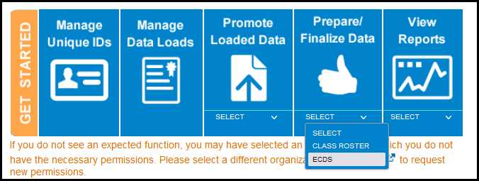

When you are ready to finalize the submission, confirm that the Data Status of your subcategories is VALIDATED.

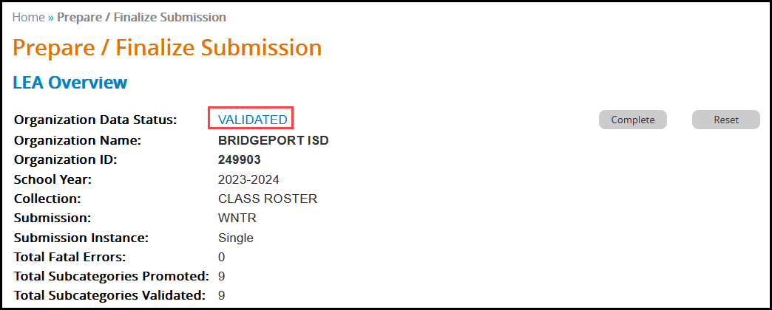

- Click Complete. This prompts another validation of the data. A Completion Process Status message appears showing the progress.
- If there are no fatals, the data returns with a status of VALIDATED

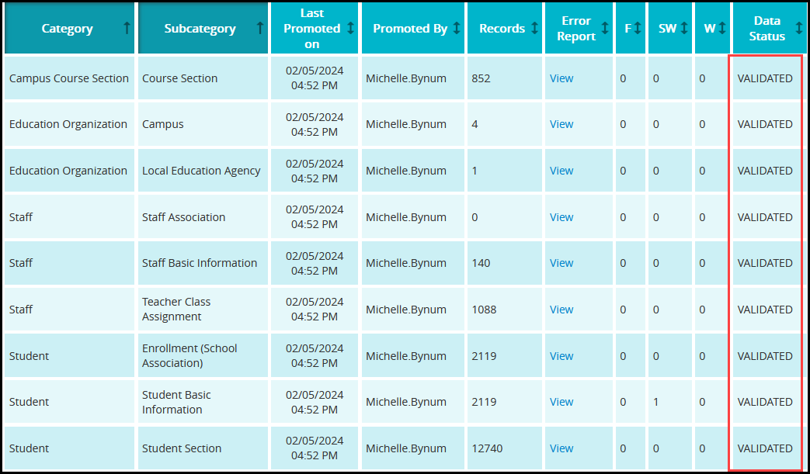

- If there are no fatals, the data returns with a status of COMPLETE.

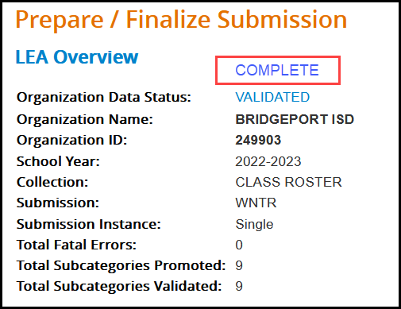

- A message appears to check the box to acknowledge the data is promoted, validated, reviewed for accuracy and authenticity, and all special warnings and warnings have been reviewed and confirmed.

Check the box and click CONFIRM.

Reset Submission

If you need to reset the data to its original state after completion, click the Reset button.

You can reset your submission until TEA’s submission due date. Once the submission is marked complete, the data status is set to LEA – DATA COMPLETE and further edits to the data are not available.

Class Roster FAQs
If a student is enrolled as of the snapshot date but does not have any courses assigned, will the student receive a fatal error?
- The student will load into the ODS, but will not be promoted since they are not enrolled in a course. This is the same for teachers that are not assigned to a course.
What happens to courses that have sections with no students enrolled or teachers assigned?
- The course sections will be promoted to the Core Collection data mart but will not print on reports. Only course sections with a teacher assigned and/or student(s) enrolled will appear on the reports.
What kind of courses/service IDs will be promoted to the Class Roster collection?

- For Winter submission, all service ID’s for all grade levels will be included.

- Exception: SERVICE-IDs that begin with “SA”, “SE”, “SR”, “SS”, or “8” should not be included and will result in a fatal warning. If the LEA uses a local service ID, the data will not be promoted.

Will Class Roster report all ADA codes?
- The Class Roster collection does not look at ADA codes.
What happens to courses that have sections with no students enrolled or teachers assigned?
- The course sections will be promoted to the data mart but will not print on reports. Only course sections with a teacher assigned and/or student(s) enrolled will appear on reports.
For the Class Roster Winter submission, should ALL teachers be reported?
LEAS will report all classroom positions;

- Teacher of Record
- Assistant Teacher
- Support Teacher
- Substitute Teacher
- PK Classroom Aide
- This will be used for Teacher Incentive Allotment.

Promotion Logic
- If a staff member has ROLE-ID of 087 or 047, then look at CLASSROOM-POSITION. If any valid CLASSROOM-POSITION, then submit for Class Roster.
Note: PK Classroom Aide - A typical PK Classroom Aide is a ROLD-ID 033 and a CLASSROOM-POSITION of PK Classroom Aide. Paraprofessionals (ROLE-ID 033) are not used by class roster and should not be reported.
What service ID should be used for EE students?
The LEAs should continue to use the same service ID they have been using for EE students’ classes.
- If the LEA uses the PK service ID, the data will be promoted to the Class Roster data collection.
- If the LEA uses a local service ID, the data will not be promoted to the Class Roster Winter data collection.
If a teacher only has service IDs beginning with ‘SA’, ‘SE’ or ‘8’, the teacher data will not be promoted to the Class Roster Winter data collection. As with the local service ID guidance stated above, the teacher data will be pulled and used for the Teacher Incentive Allotment.
How should an LEA report an active DAEP/JJAEP campus when there are not any students enrolled on the Snapshot date?
The EducationOrganization interchange with the following complex types should be reported;

- LocalEducationAgency
- SchoolExtension
- Class Period
- Location
The LEA must report a campus record for every active instructional campus. The class period and location reference are mandatory for TSDS collections. When submitting the School extension for JJAEP and DAEP, the LEA will use their normal class periods. For the Location extension, if there are not classrooms already designated, the LEA will need to set up a default classroom.
However, the LEA does not need to report any campus course sections, student data or staff data if there were no teachers assigned or students enrolled in courses on the snapshot date. The LEA will receive special warnings for no courses, staff and students, which they can verify and ignore for that campus.
How do LEAs report centrally assigned designated teachers for TIA?
Centrally assigned teachers designated for TIA should be reported with a TeacherSchoolAssociation with a campus number ending in 999. In addition, the Staff complex type would be promoted since the staff member has a TeacherSchoolAssociation record, and their role ID is an 087.
Can an LEA report more than one TEACHER-INCENTIVE-ALLOTMENT-DESIGNATION-CODE (E1722) per teacher?
Yes, a teacher may have and be reported with more than one TEACHER-INCENTIVE-ALLOTMENT-DESIGNATION-CODE (E1722).
When will the LEA report their TIA teachers during the Class Roster Winter collection if an LEA has a “data capture year” of 2023-2024?
LEAs in the data capture year should not report TIA data elements to TEA during the Class Roster Winter submission.
Can an LEA submit a TeacherSchoolAssociation complex type for each CAMPUS-ID (E0266) where the teacher provides instruction?
Yes, the LEA should report a TeacherSchoolAssociation complex type for each CAMPUS-ID where the teacher provides instruction if the teacher (ROLE-ID 087) is reported with a TEACHER-INCENTIVE-ALLOTMENT-DESIGNATION-CODE (E1722) on the StaffExtension complex type and the teacher is not reported with a TeacherSectionAssociationExtension complex type.

ADDITIONAL INFORMATION / RELATED KB ARTICLE(S):
- 2023-2024 TWEDS: Class Roster Collection
- 2023 Spring Training Presentations
- 2023 Summer Training Presentations
- ESC TSDS Champions
- There is no resubmission for Core Collections
- SOA is not required for Core Collections

TSDSKB-619
CR: Teacher Incentive Allotment for Class Roster Winter Collection FAQ:
How is the Teacher Incentive Allotment information being sent to an LEA’s Human Resources (HR) department?
The Teacher Incentive Allotment (TIA) program area sends information directly to the LEA HR department via email. More information can be found in the Teacher Incentive Allotment (TIA) Update and Information TAA letter released on 9/3/2020.
The TIA program area has a designated TIA point of contact for approximately 800 LEAs. PEIMS Fall data is used to determine if an LEA has designated teachers.
If an LEA does not have a TIA point of contact, the program area will contact the ESC and request contact information for their human resource and business offices.
Will an LEA receive Teacher Incentive Allotment funding when they have a designated teacher employed by their district, but does not participate in the program?
Yes, all LEAs can receive TIA funds if they employ a designated teacher. A local designation system is not required to receive funding.
What is a CREDITABLE-YEAR-OF-SERVICE?
A creditable year of service for the teacher incentive allotment purposes is defined as:
By the end of the school year, the teacher will have been employed by the reporting district as a teacher (ROLE-ID 087) and compensated for that employment for a minimum of 90 days at 100% of the day (equivalent to four and one-half months or a full semester) or 180 days required at 50-99% of the day. (19TAC§153.1021)
What is an approved designation?
A designation is a distinction issued to highly effective teachers. The Teacher Incentive Allotment allows approved LEAs to issue designations to highly effective teachers. There are three levels of designation: Recognized, Exemplary, and Master. Designations are displayed on teacher certificates. National Board-Certified teachers earn a Recognized designation automatically. Eligible designated teachers will generate an allotment for their LEA each year based on their campus of employment.
Should an LEA report the new Teacher Incentive Allotment information in both Class Roster collections or only in the Class Roster Winter collection?
The Teacher Incentive Allotment information is only reported in the Class Roster Winter Collection.
On the TeacherSchoolAssociation complex type, does an LEA need to send information about the classes the teacher is teaching?
An LEA will only report the Staff Unique ID and Campus ID on the TeacherSectionAssociation.
For the Teacher Incentive Allotment (TIA), which campus TIA funding amount would be used when a teacher is reported at more than one campus?
When a teacher is reported at more than one campus, an average of the campuses will be used. The TIA Division does not look at time spent on each campus. The TIA Division can manually override the funding amount in special circumstances.
Example of special circumstances: teachers at one campus with students who commute from other campuses to the teacher's campus.
The TIA Division would develop an average over the students' campuses and can manually override the funding amount in special circumstances.
ADDITIONAL INFORMATION / RELATED KB ARTICLE(S):
- https://tiatexas.org/
- TAA Letter – September 3, 2020
- Teacher Incentive Allotment Designations
- 2023-2024 TWEDS: Class Roster Collection
- TSDSKB-587 – CR: General FAQs for Class Roster Collection
- TSDSKB-619 – CR: Teacher Incentive Allotment for Class Roster Winter collection

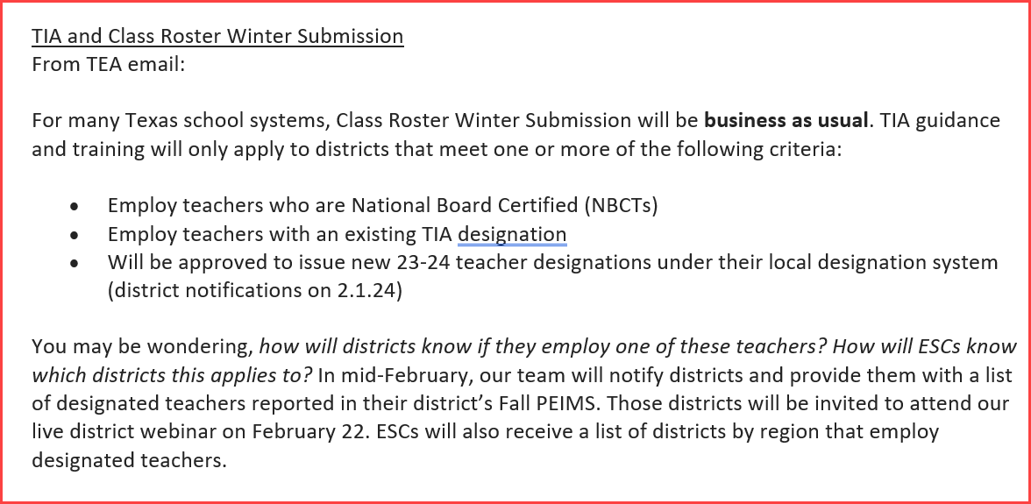

ESC Region 11 grants permission to attendees of this session to reproduce and distribute designated resources and materials provided during the presentation.

